Reminder: This is not homework; it is for parent information.

Math News

**Essential Question:** What strategies can you use while adding and subtracting?

**Count On To Add:** 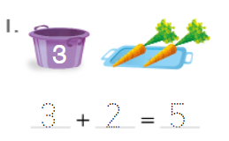

**Doubles:**

**Near Doubles:**

**

**Vocabulary:**

Count Back  Doubles  Near Doubles Fact

Number line 

**Standards:**

1.OA.C.5

1.OA.C.6

1.OA.B.3

1.OA.B.4

1.OA.A.1

**Add in Any Order:**

**Count Back to Subtract:**



**

**Solve Word Problems with Facts to 10:**